1. **Take Exit 12B, Rte. 291- Cargo City**

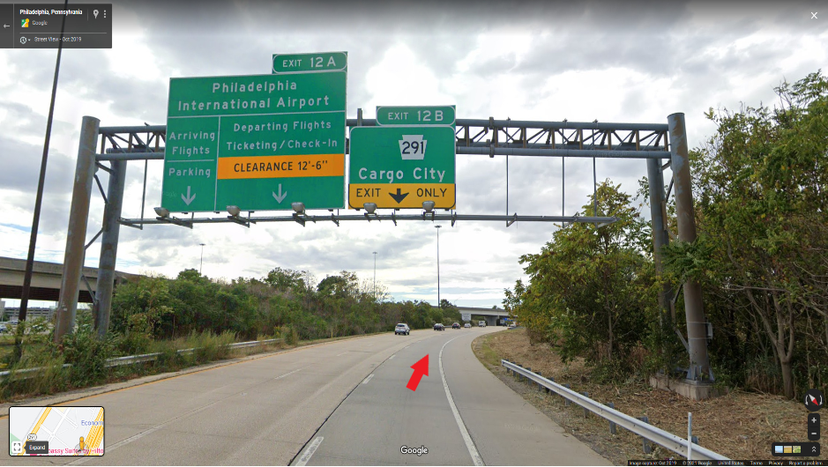

1. **Make a left unto Rte. 291/Bartram Ave. at the traffic light at the end of the exit ramp towards Cargo City/Lester.**

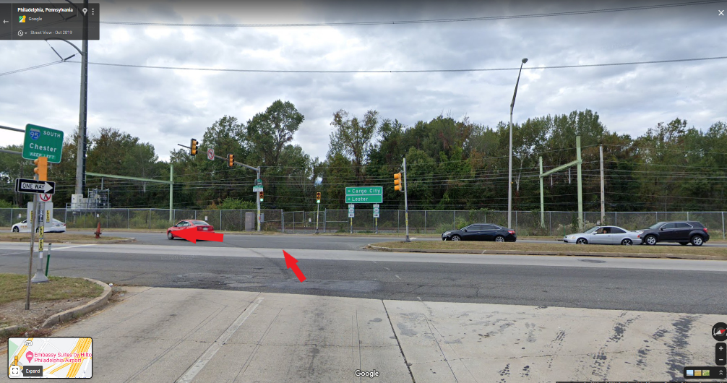

1. **Make a left unto Industrial Highway at "Wally Park".**

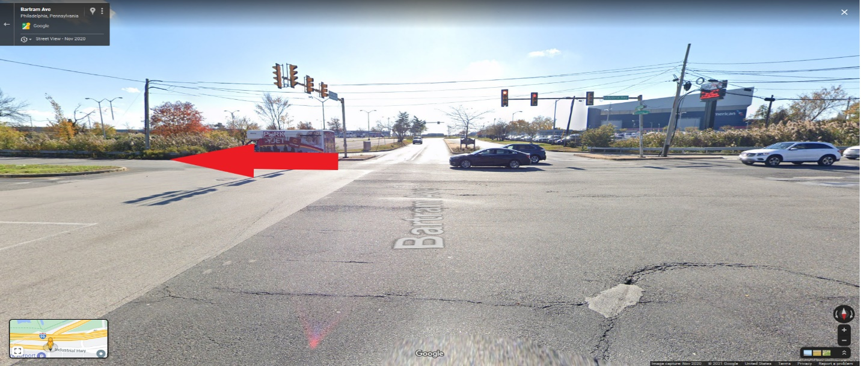

1. **Follow Sign For Arriving Flights**

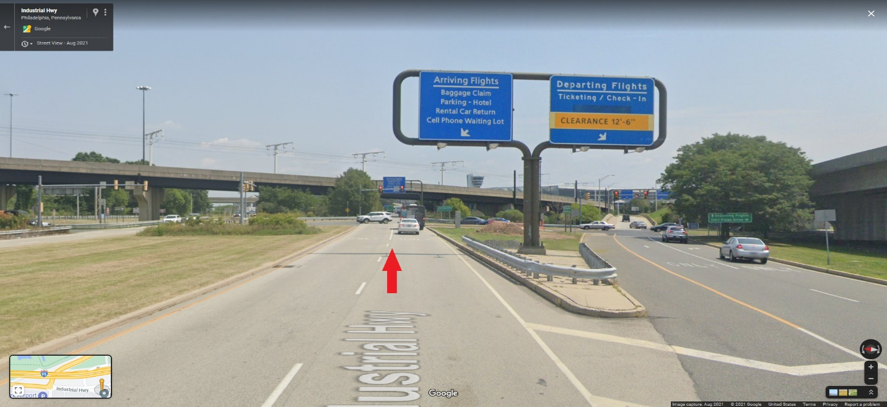

1. **Follow signs for Uber/Lyft to the sign that says "Commercial Vehicles Only" and stay to the right**

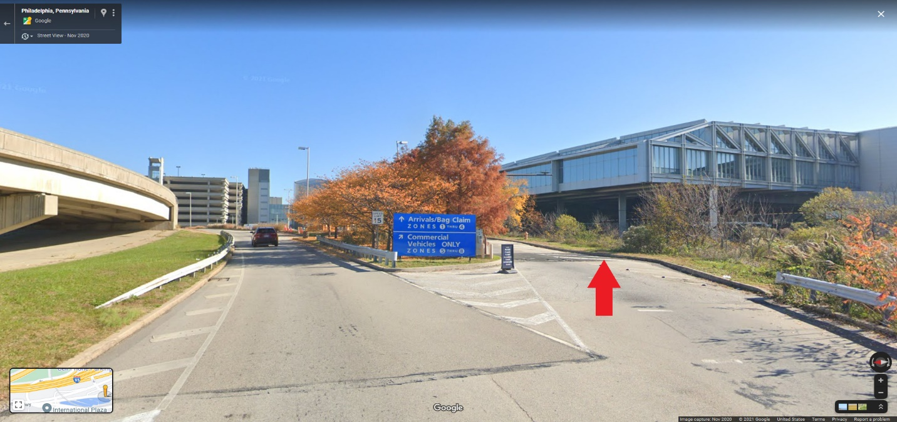

1. **When you access the lot through the gate arms, follow the Uber/Lyft sign to the right. Follow this road past the hold lot and it will bring you directly to the South Commercial Road at Terminal A. Continue on South Commercial Rd. to the multipurpose lot.**

