How to Update Your Emergency Contact Information
In this quick reference guide, you will learn how to update your emergency contact information in the OnePhilly Employee Self Service portal.
To begin, hold the CTRL key down on your keyboard and click on this https://ess-onephilly.phila.gov URL. Once you arrive at the Employee Self Service landing page, click the icon at the top left-hand corner of the page, then click COP HR Employee Self Service, City of Philadelphia. Finally, hit the down arrow on your keyboard until you find the Personal Information option. Click that link to launch the page.

On the Personal Information page, scroll to the bottom of the screen and click the Add button to add a new Emergency Contact: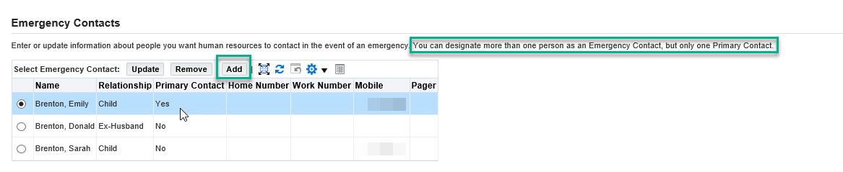
Next, you will see the following screen. (Please note the green box around the Relationship field, as it is important.)
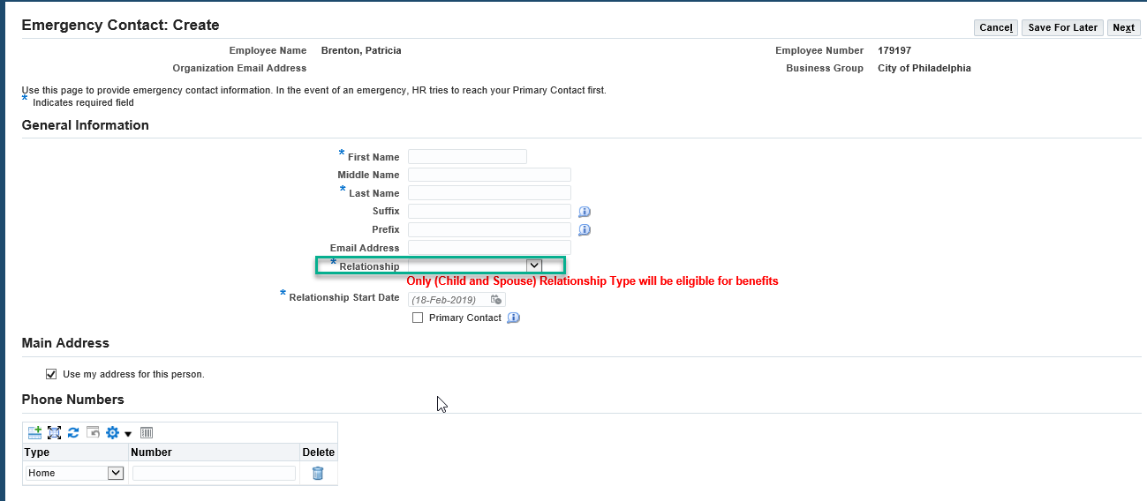

Fill in the required fields, taking special care to pick the correct value in the Relationship field. There are 52 options, including next of kin. Whatever you put here will show up on the Emergency Contact listing for that person.
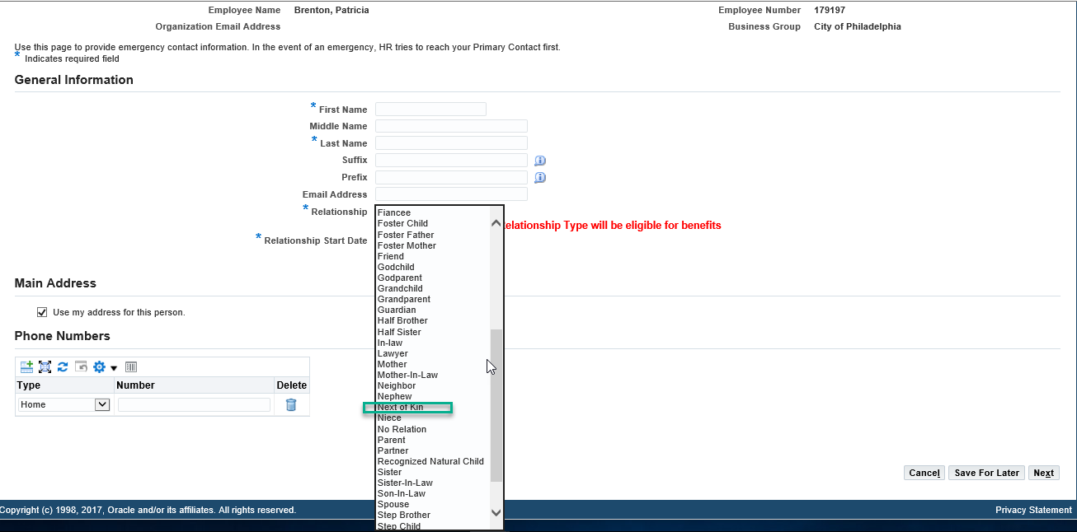

Now that you understand the basics, let’s see how it all comes together. In the following pages, you will see learn how to designate a person to be your emergency contact.
First, let’s take note of the emergency contact screen’s key features. Check the Primary Contact box if you want the person to be called first in case of emergency. Check the Main Address box if you want that person affiliated with your home address. Also, take note of the numerous phone number types at the bottom of the page.

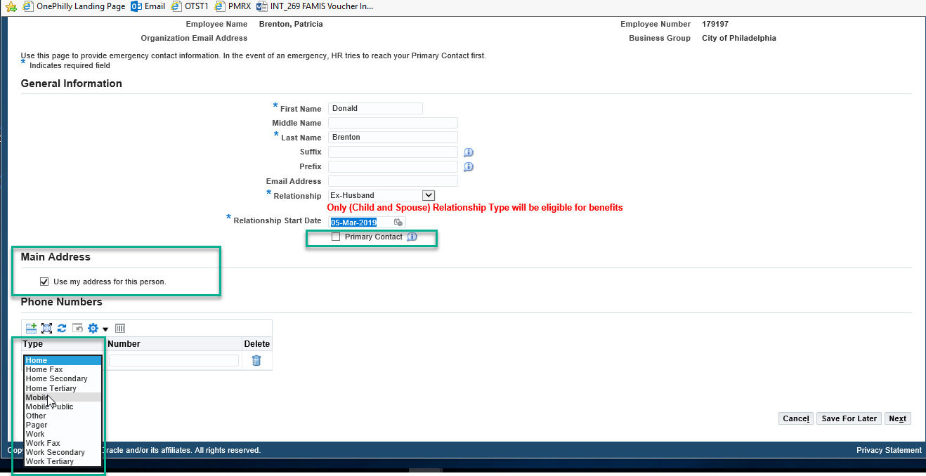
In the example below, the employee did not affiliate the emergency contact with their Main Address. Therefore, the employee must fill in additional address fields for the contact.
Once a City name is entered, the system will show “Loading,” and then all possible matches will display.
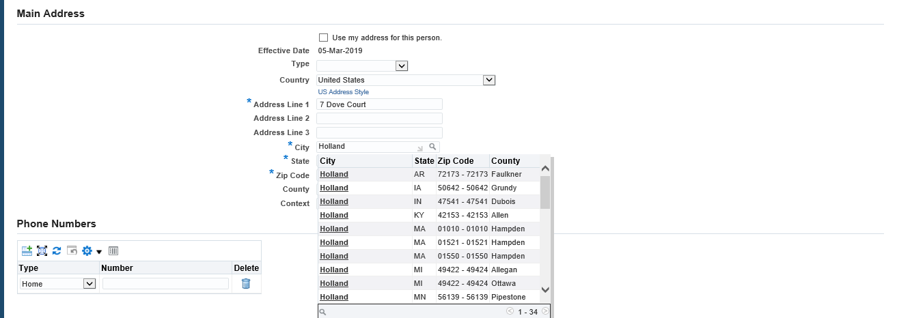

Once you click on an option, the following screen will appear. Click on the circle next to the correct combination of City, State, Zip Code and County. Then, click the Select button in the upper righthand corner of the screen.
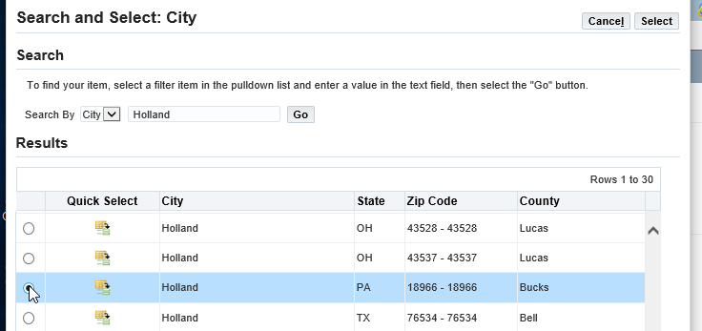

The address information on your emergency contact screen should now match your selection. Click the Next button to continue.

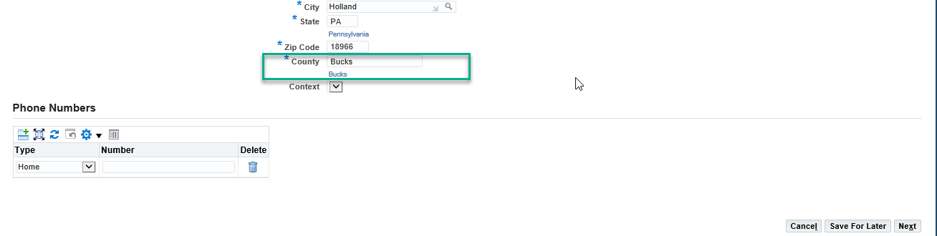

Review the information you have entered. If it is correct, click the Submit button in the upper righthand corner of the page.
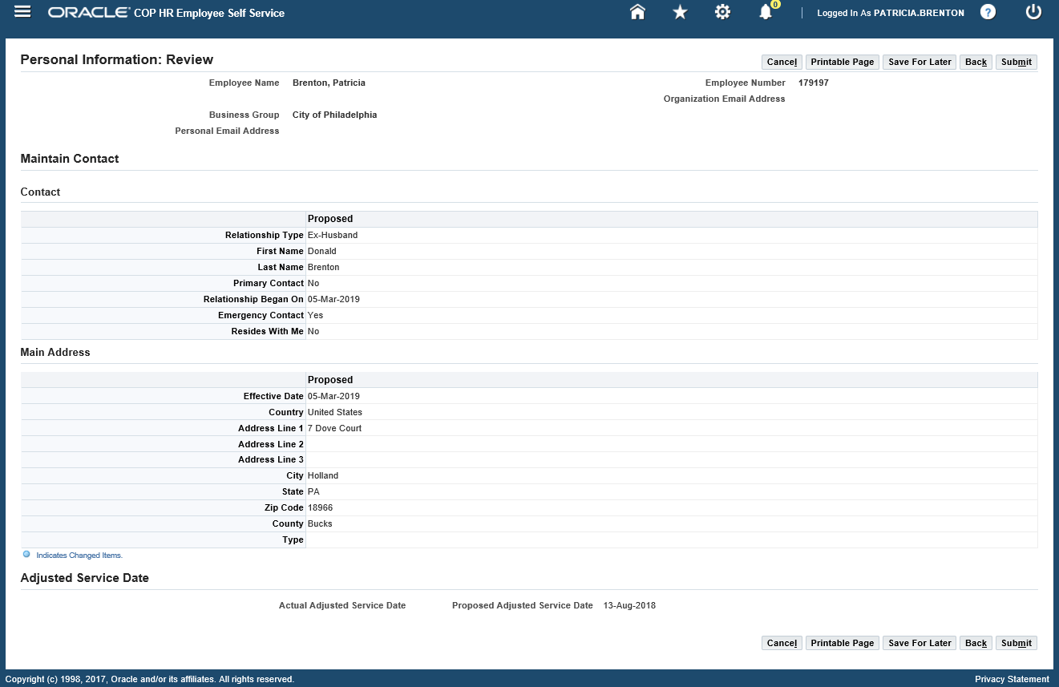

You will now see a Confirmation screen, showing that your changes have been made.

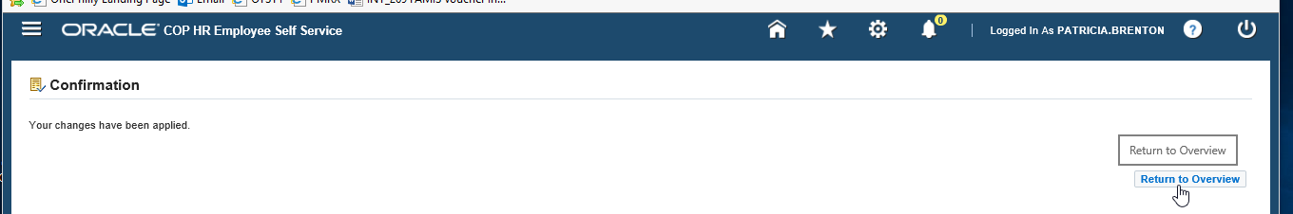

Click on Return to Overview and you will see the employee’s complete list of Emergency Contacts. Notice that the new contact has been added to the list, and that the primary contact remains the same.
